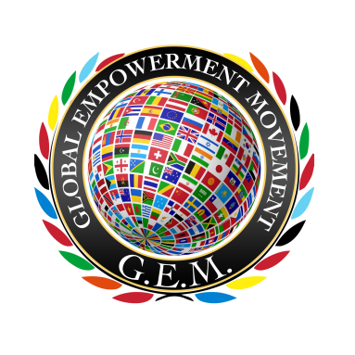
Global Empowerment Movement

Acts 20:35 “….I have been a constant example of how you can help those in need by working hard. You should remember the words of the Lord Jesus: ‘It is more blessed to give than to receive.’” NLT

Jesus, how he himself said, ‘It is more blessed to give than to receive.”

It takes a Community to empower lives! Join us as a GEM HOST

You Can Make A Difference
- Change your perception, Dignify the Needy
- Connect with us on Facebook, Twitter, Instagram, and then share with your friends and keep up to date with our events, partners, and news.
- Volunteer your time and resources, support the needy with your surplus
- Donate $50 to Global Empowerment Movement, so we can continue to advocate for Women In Need (WIN) and Single Mothers and Children in Distress (SMACID)
- Host event, host your party in honor of Dignifying the Needy

To learn more about how you can host an event or go online to: www.globalempowermentmovement.org

Host An Event Party
Thank you for hosting the “Dignifying the Needy with our Surpluses”

Below are a few suggestions:
You may want to consider when hosting your party.
Distribute our useful resources to your guests.
• Guide for Host
• Donation Form
• Sign In Form

Guide For Hosting Event

Before Your Party

Visit www.globalempowermentmovement.org to learn more about my mission.

Invite your community to the Event:
  - Family Members
  - Friends
  - Colleagues
  - Partner Organizations
  - Churches
  - Local Council Members
  - Local Community Organizations in Your Area

Don’t be afraid to ask for contributions, the proceeds funds Global Empowerment Movement

Your friends will appreciate your appeal for a good cause.
Global Empowerment Movement is dedicated to helping you host the best event for the Dignify the Needy Initiative.

How Can I Fundraise?
- Suggest a minimum amount and use a range of options ($ 500, $100, $50, $20, other).
- Pass out individual donation cards, an empty envelope or leave a basket in the middle of the room for donations.
- Direct your guests to my website to learn more about me, my organizations, and to make a donation online.

Have fun and remember every little bit helps!

After Your Party
Contact us to request mailing address to submit donation forms and send the complete event Sign In Form via e-mail. globalempowermentmove@gmail.com

