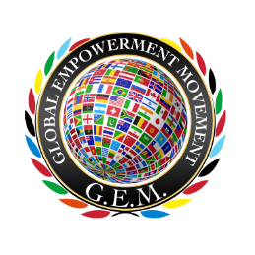
Global Empowerment Movement (GEM)

Acts 20:35 “….I have been a constant example of how you can help those in need by working hard. You should remember the words of the Lord Jesus: ‘It is more blessed to give than to receive.’” NLT

Jesus, how he himself said, ‘It is more blessed to give than to receive.”

It takes a Community to empower lives! Join us as a GEM HOST

Event Sign In Form

# | Name | Email | Address | Phone Number | Add to Mailing List?

***This Sign In Form must be returned to Global Empowerment Movement in order to receive a free copy of “Beauty Enslavement” and other Global Empowerment Movement Perks*** Please send the completed Event Sign In Form via email to Global Empowerment Movement at globalempowermentmove@gmail.com

